Neural Network Learning Process
Used neural network learning by using a fully connected feedforward architecture with two hidden layers. The network consists of the following key components:
- Input Layer: 11 features representing the characteristics of wine samples.
- Hidden Layers:
  - First hidden layer with 16 neurons using the Leaky ReLU activation function.
  - Second hidden layer with 32 neurons also using Leaky ReLU.
- Output Layer: Softmax activation function to classify wine quality into multiple categories.

Step-by-Step Explanations

One-Hot Encoding
One-hot encoding is used to convert categorical labels into binary. Since wine quality is a multi-class classification problem, each unique quality score is represented as a vector with one position being '1' and the rest being '0'.

Dataset Splitting and Stratification
The data is split into test, validation, and training sets. Stratification is applied to ensure that all sets have the same class distribution. This prevents class imbalance issues, thus each data subset has an equal ratio of each of the wine quality scores.

Data Scaling and Its Importance
Feature scaling using StandardScaler scales the data so that all input features have a mean of 0 and a standard deviation of 1. This prevents features with large numerical ranges from dominating those with small values, accelerates gradient descent convergence, and stabilizes learning, thus improving model performance.

ReLU and Softmax Functions in Training
- ReLU (Rectified Linear Unit): Used in hidden layers to introduce non-linearity so that the model learns complex patterns.
- Softmax: Used in the output layer to convert raw scores into probabilities, ensuring that the sum of all output values is 1, making it suitable for multi-class classification.

Forward and Backward Propagation
Forward propagation is the method through which the input data passes through the network layer by layer. Weighted sums are computed at each layer, followed by activation functions (ReLU for the hidden layers and Softmax for the output layer) to obtain predictions.
Backpropagation calculates the gradients to minimize the error. It is calculated by finding the gradient of the loss function for the output and then back propagating the error through the network based on the chain rule. The weights are then adjusted with calculated gradients in order to reduce the error and improve the performance of the model.
Loss is calculated using categorical cross-entropy.
Weight Updates in Training
Weights are updated according to gradient descent: W=W−α⋅∂L/∂W where α is learning rate and ∂L/∂W is the loss gradient with respect to weights.

Loss and Accuracy Over Time
Training and validation loss decrease over time as training continues, which is a sign of good learning, while accuracy improves, which is a sign that the model learns patterns well. Overfitting is prevented by applying early stopping, where training is terminated when validation loss no longer decreases, thereby enabling improved generalization.
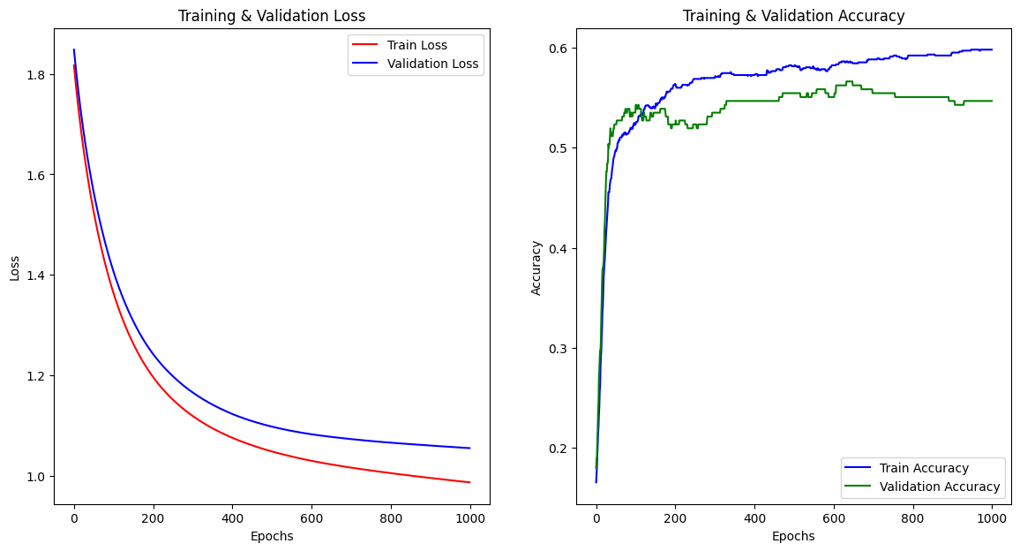

Classification Report
The final classification report provides precision, recall, and F1-score for all wine quality categories, indicating how the model performs at different quality levels.
